REPLACING A MISSING FRONT TOOTH

Q What options are there for replacing a missing front tooth?

A There are five options for replacing a missing front tooth. Which of the solutions available will be suitable depend on an individual’s circumstances. The five options are as follows:

- Acrylic Denture
- Maryland or Resin Bonded Bridge
- Chrome Frame Denture
- Conventional Bridge
- Implant

Q What is an Acrylic Denture?

A An Acrylic Denture is one made from durable plastic. It is often used as an interim solution before one of the other methods detailed below are used.

Acrylic dentures are able to restore many teeth in one go. They are the standard NHS treatment.

To be strong enough and stay in place acrylic dentures have to be 2-3 mm thick and often cover a large surface area.

Acrylic Dentures cover a lot of gum edges; therefore, the risk of decay and gum disease is increased. The coverage of the palate can alter taste sensitivity. They rely on suction or additional clasps for retention.

Good aesthetics are possible with these dentures. They are low cost and easily repaired.

Q What is a Maryland or Resin Bonded Bridge?

A A Maryland Bridge is a prosthetic tooth that uses a metal wing bonded to the next tooth to hold it in place. It is named after the University of Maryland that pioneered the technique.

The bridge unit is made by a dental laboratory to replace the missing tooth. It has a thin metal wing that accurately fits the back (palatal) surface of an adjacent tooth. The tooth will normally need some minimal adjustment to allow the bite to be correct afterwards. The wing is then bonded to the adjacent tooth.
Good aesthetics are achieved and minimal preparation to the adjacent tooth is required. Once fitted, it can be treated as any other tooth. It is a relatively low cost solution.

Over time it could detach and need re-bonding. Sometimes the winged tooth may darken owing to reduced light transmission. A totally plastic version is now available that can avoid this problem.
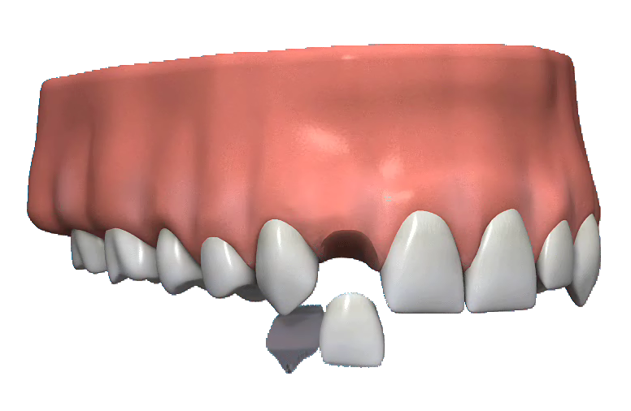

Q What is a Chrome Frame Denture?

A A Chrome Frame Denture is where the main structure is built from a casting of thin stainless steel. Normal acrylic denture teeth are attached to this frame.

There can be minimal movement of the front tooth. There needs to be clasps around the back teeth to stabilise the denture. There is some increased risk of gum disease or decay in the areas the denture covers.

It is a mid priced solution that gives very good aesthetics. There is little damage to surrounding teeth and the chrome denture can accommodate more than one missing tooth.

Q What is a Conventional Bridge?

A A conventional bridge uses the support of one or both of the teeth surrounding the gap. This support is a full coverage crown.

There will be extensive and irreversible loss of tooth structure to one or both surrounding teeth. The tooth or teeth to be crowned will need to be substantially reduced to take the crown.

This mid priced solution works well when the surrounding tooth/teeth are either discoloured, or have poor aesthetics, or heavily restored or already crowned. The service life is about 15 – 20 years.

If the bridge is damaged it can be difficult to repair and is unsuitable for patients with an ‘active’ lifestyle or those with gum disease.

Q What is an Implant?

A An Implant is where a cylinder of titanium, with a machined central post space, is placed in a carefully prepared hole in the jaw bone. This is then left for a few months for the bone to grow up to and around the implant to hold it firmly in place. Once firmly in place the implant is then uncovered, a post inserted and a crown made to fit the post.

A temporary solution will be needed to fill the gap whilst the bone is securing the implant. It is an expensive solution and requires surgery.

It is cutting edge technology with near perfect aesthetics achieved. Avoids any damage to other teeth. It is a fixed and permanent solution with a 98% success rate.

